Lab Assignment – 3

Harsh Vardhan Kushwaha

17BCN7017

1. Find the employee names having greater than Rs. 25000.

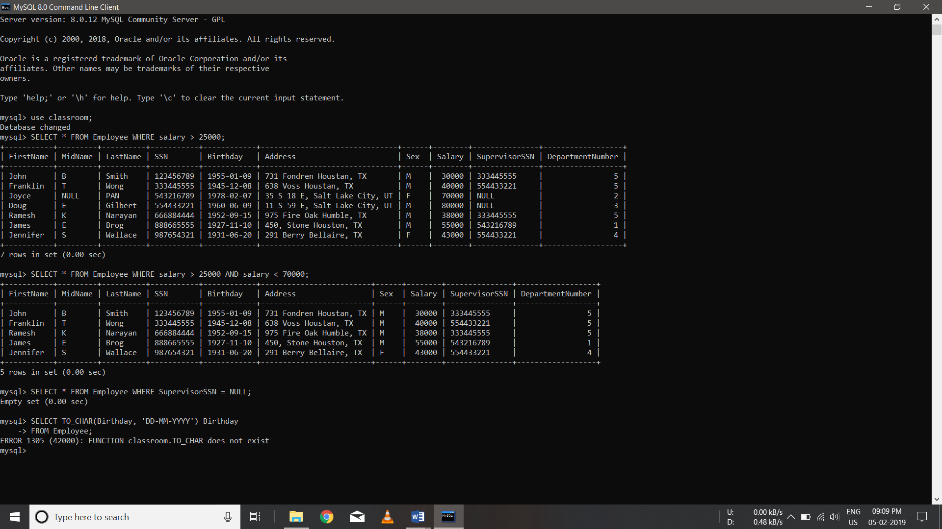

1. Find the employee names whose salary lies in the range between 30000 and 70000.



1. Find the employees who have no supervisor.



1. Display the birthdays of all employees in the format ‘DDMMYYYY’.

SELECT TO_CHAR(Birthday, 'DD-MM-YYYY') Birthday FROM Employee;

1. Display the employee names whose birth date is on or before 1978.

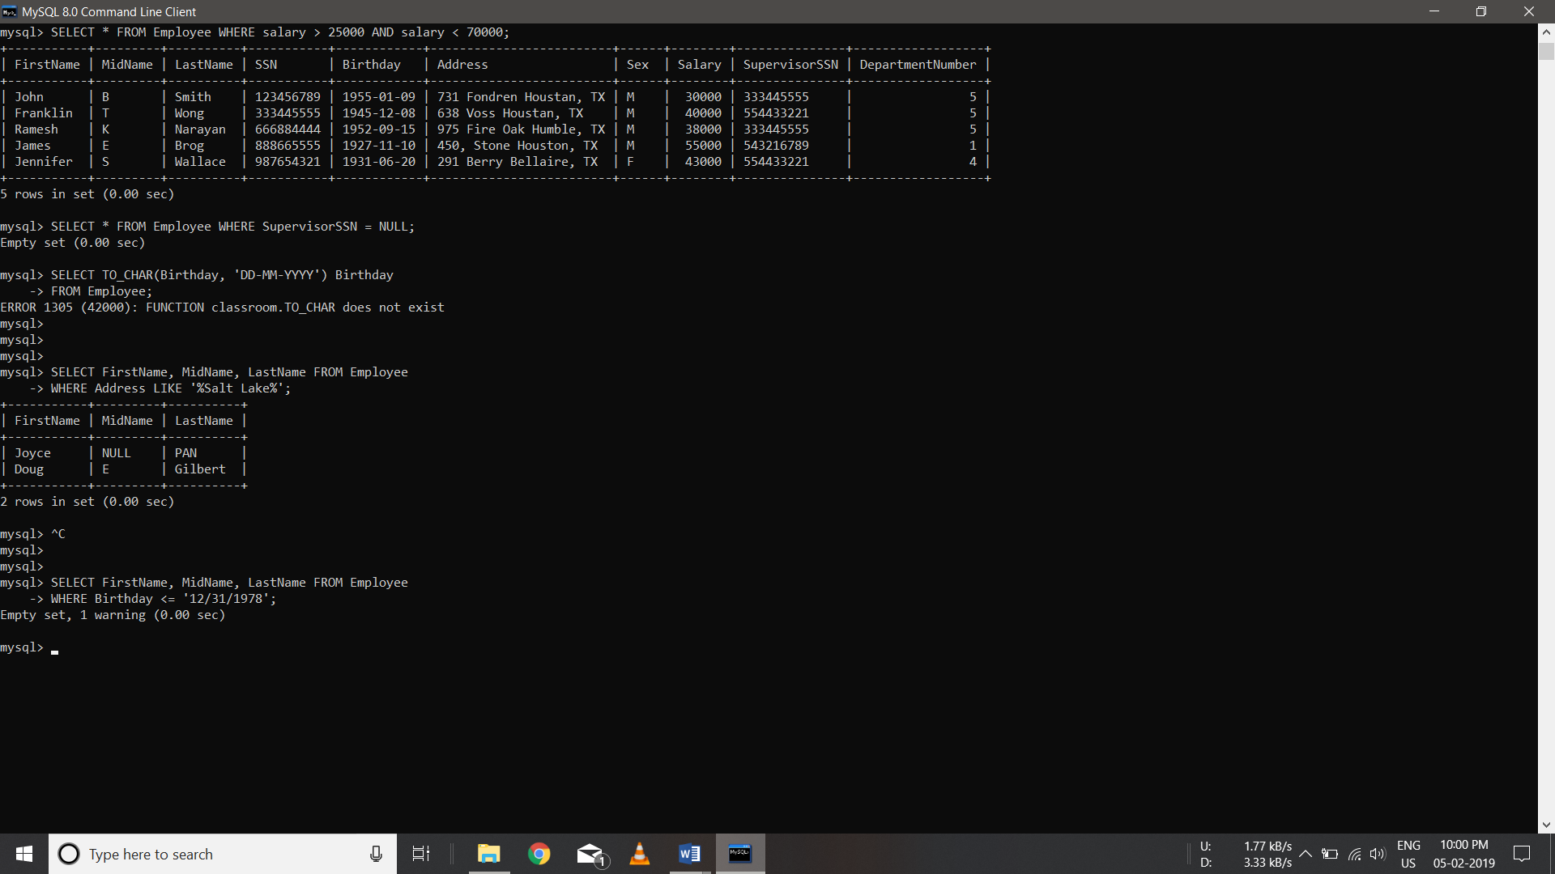

1. Display the employee names having ‘Salt Lake’ in their address.

